The Battery Vampire 2.0

Project Team: Bruno Da Silva, RJ Dalusung, Yanal Matar, Ryan Rolle

*Electrical and Computer Engineering*

Project Number ECE 24-401

Faculty Advisor and Mentor: Gary Atkinson, Ph.D.

Every year billions of dollars are spent on new batteries. When a battery powered device stops working the average user assumes that the battery is now dead and should be either thrown away or put in a specific drawer with the intent of recycling. However these batteries are not dead, instead they have just dropped below the threshold which the device it was powering required in order to power on. The Battery Vampire 1.0 took energy from batteries and used this energy to fill a battery pack whereas our project focuses on greater efficiency and also battery to battery charging. The Battery Vampire 2.0 takes the energy from the otherwise useless “dead” batteries and uses that energy to restore power to an empty rechargeable battery. The device manages this by taking the steadily decreasing voltage from a series of dead batteries and then using a buck boost converter to output a stable charging voltage which is then fed into the dead rechargeable battery. Our device succeeds in taking energy from AA batteries and using this energy to recharge an empty rechargeable AA battery back to its normal charged state.

Keywords: Battery, Energy, Sustainability

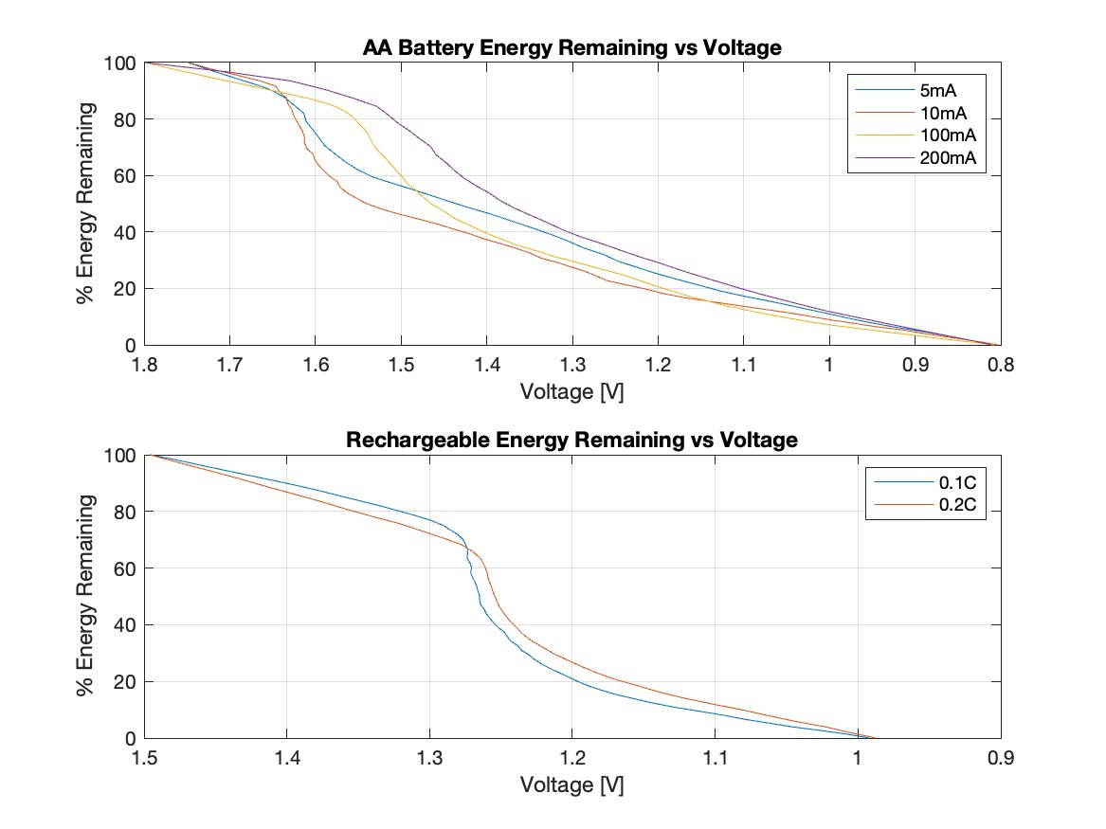

The Battery Vampire 2.0 Circuit Diagram